BIG Binder Setup
Keep this in your binder during the school year!

You will be using one big binder for all of your classes:
Science,
English Language Arts (ELA), Mathematics,
Social Studies,
Flex or AVID,
and Encore or Language!

The Purpose of the Big Binder
- To practice organizational skills (and keep everyone organized in the same way),
- To create a portfolio of your work,
- To help everyone study for tests and quizzes, &
- To prepare you for class each day.

Materials to Create Your Big Binder
*As listed on your supplies list, the supplies below are NOT in ADDITION to those listed on your supplies list.
- 1 BIG Binder (2 – 3”) or zipper/velcro binder
- Franklin assignment notebook or assignment sheet(s)
- 1 hole-punched pencil pouch
  - Pencil(s), pen(s), highlighter(s), etc.
- 7 hole-punched pocket folders (WITHOUT metal studs)
- 7 hole-punched tab dividers
- Lined paper

When and How Do You Use Your Big Binder?
You will need your binder for every class, every class period, every day. You will use your binder to organize assignments, homework, projects and much more. You will store your notes under the tabs and study these during class and at home on a regular basis.

Grading
Your binder will be graded bi-weekly in your flex or AVID class. They will need to be organized and used regularly to receive full credit. You’ll get more details about how to get your binder ready to be graded later, along with example rubrics to prepare you!
Binder Setup
This will be done in your flex class during the first week of school. The binder should be set up in the order that you have your classes. For example if the order of my classes is Spanish, Math, AVID, Social Studies, ELA, Science, then my tabs will go in that order, followed by my folders going in that same order.

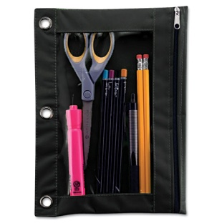
Front to Back
- Pencil pouch with pencil(s), pen(s), highlighter(s), eraser(s), etc.

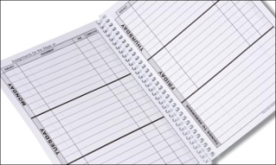
- Franklin assignment notebook, or assignment sheet(s)

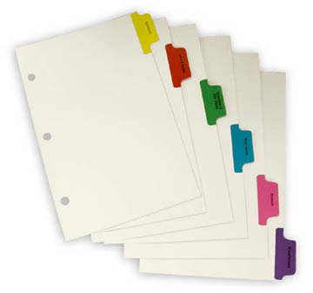
- Tab dividers labeled in the order of your classes

Example: 1. Spanish, 3.Math, 4.AVID, 5.Social Studies, 7. ELA,
8.Science, Paper

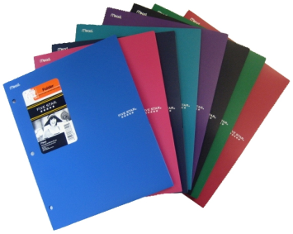
- Folders labeled in the order of your classes

Example: 1. Spanish, 3.Math, 4.AVID, 5.Social Studies, 7. ELA,
8.Science, Other

- Make sure every tab, and every folder are labeled correctly!

If you need help getting these binder supplies, please let one of your teachers know as soon as possible so we can help get you organized and set up for a successful school year!

