COLLEGE COMMERCIAL
8th Grade- Due Thursday, May 9, 2013
You have selected ____________________________________________________.
Purpose: You will be making a commercial for the above college/university. Your commercial should accurately represent the university/college and make students of AVID and Franklin want to visit your university/college.
You will be graded on two parts, the commercial and the written paper. The paper will represent the research and include the works cited, the commercial will be your presentation. You will have time in the computer lab to work on your written paper and commercial.
- Written Paper
- Microsoft Word requirements:
  - At least one page in length
  - TYPED
  - 12 point, Arial, BLACK font (The font you are reading on this paper is 12 point, Arial font with 1 inch margins.)
  - 1 inch margins on each side
  - Single-spaced (NOT DOUBLE SPACED)
- The order of your paper should be as follows:
  - Title Page – include your name, date, AVID class period and college name
  - Written Paper – (typed and at least one full page in length)
  - Works Cited Page – as outlined and discussed with teacher
  - KWL Chart – chart that includes all your research information
  - Cover – plastic or a folder that is in GOOD SHAPE or NEW
- Your paper should include the following information about your school:
  - Location & age of school
  - School mascot
  - Undergraduate admission requirements
  - Student enrollment
  - Tuition Costs
  - Room & Board (Dorms and/or Private Housing)
  - Student Life (Greek life, student organizations, libraries, rec center, athletics and residence life)
  - Most popular or top-rated majors
  - Interesting Facts
- Extra credit topics you can include for additional points:
    - Financial Aid Office
    - Health Services
    - Campus Safety
    - Career Services
    - Counseling
    - Campus Job Opportunities
    - Transportation/Parking
    - Tutoring
- Research Project Reflection Worksheet

- Commercial
The sky is the limit when it comes to your commercial. Be as creative as you would like, remember it will be shown not only to your AVID class, but the school population as well during AVID College Night.

You must include the following things:
→Location & age of school, school mascot
→Undergraduate admission requirements
→Tuition Costs and scholarships available
→Student Life, including campus activities (Greek life, student organizations and residence life)
→Make sure to include your name!
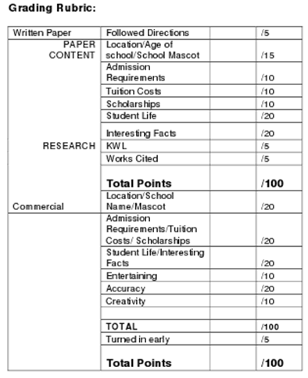
Name: _________________________________ College: _______________________________________
College Research Project Reflection Worksheet
DIRECTIONS: Answer the following questions in complete sentences.

1. What was the most interesting fact you learned about your college?

2. As a result of your research, do you think this school might be right for you? Please explain the reasons why or why not?

3. What was your favorite part of completing the project?

4. What suggestions do you have to improve this research project for future AVID students?

